**What are Entity Relationship Diagrams?**

Entity Relationship Diagrams (ERDs) illustrate the logical structure of databases.

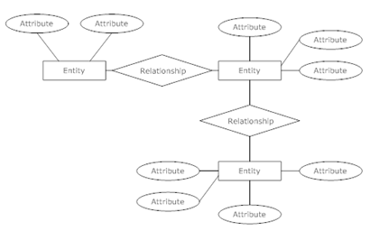  
*An ER Diagram*

**Entity Relationship Diagram Notations**

[Peter Chen](http://www.csc.lsu.edu/~chen/chen.html) developed ERDs in 1976. Since then Charles Bachman and James Martin have added some sligh refinements to the basic ERD principles.

**Entity**

An entity is an object or concept about which you want to store information.  
[Learn how to edit text on an entity.](http://www.smartdraw.com/resources/tutorials/Text-and-Tables)

Entity

**Weak Entity**

A weak entity is an entity that must defined by a foreign key relationship with another entity as it cannot be uniquely identified by its own attributes alone.  
[Learn how to edit text on this object.](http://www.smartdraw.com/resources/tutorials/Text-and-Tables)

Weak Entity

**Key attribute**

A key attribute is the unique, distinguishing characteristic of the entity. For example, an employee's social security number might be the employee's key attribute.

Key attribute

**Multivalued attribute**

A multivalued attribute can have more than one value. For example, an employee entity can have multiple skill values.

Multivalued attribute

**Derived attribute**

A derived attribute is based on another attribute. For example, an employee's monthly salary is based on the employee's annual salary.

Derived attribute

**Relationships**

Relationships illustrate how two entities share information in the database structure.

Learn how to draw relationships:  
First, [connect the two entities](http://www.smartdraw.com/resources/tutorials/Drawing-ER-Diagrams-1), then [drop the relationship notation on the line](http://www.smartdraw.com/resources/tutorials/Drawing-ER-Diagrams-2).

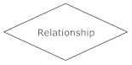

**Cardinality**

Cardinality specifies how many instances of an entity relate to one instance of another entity.

Ordinality is also closely linked to cardinality. While cardinality specifies the occurences of a relationship, ordinality describes the relationship as either mandatory or optional. In other words, cardinality specifies the maximum number of relationships and ordinality specifies the absolute minimum number of relationships.

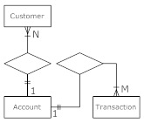  
[*Click here for more cardinality notations*](http://www.smartdraw.com/resources/tutorials/Cardinality-Notations)

[To learn how to express cardinality in SmartDraw, click here.](http://www.smartdraw.com/resources/tutorials/Drawing-ER-Diagrams-2)

**Recursive relationship**

In some cases, entities can be self-linked. For example, employees can supervise other employees.

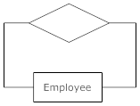

## Tips for Effective ER Diagrams

**1)** Make sure that each entity only appears once per diagram.

**2)** Name every entity, relationship, and attribute on your diagram.

**3)** Examine relationships between entities closely. Are they necessary? Are there any relationships missing? Eliminate any redundant relationships. Don't connect relationships to each other.

**4)** Use colors to highlight important portions of your diagram